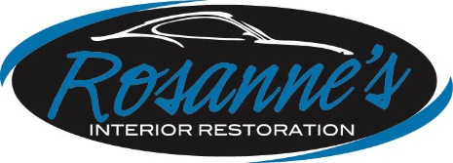
2850 Day St Sunnyside, MB R5R 0H7 PHONE:204-222-5041 FAX:204-222-5481
EMAIL: wpgrv@hotmail.com WEBSITE: winnipegrvserviceandrepair.ca

March 27, 2020

RE: COVID-19 Pandemic

Dear Valued Partners and Customers,

First, I’d like to let you know that we are open for business. We have incorporated Social Distancing into our operations in order to help prevent the spread of this virus.

As you may know Winnipeg RV and Rosanne’s Interior are accredited with MPI to perform remediation and disinfection of vehicles and RVs affected by mould, hantavirus, fire, and other situations regarding Public Health.

The same products we use for hantavirus are effective in killing new and emerging viruses such as COVID-19. This information is available on the CDC and Health Canada websites.

We are currently performing disinfecting services for several trucking companies and rental car agencies. We can provide Certificates of Disinfection as needed. Appointments can be made by phone or e-mail.

Additionally, we are still performing windshield replacements, Safety Inspections up to 8900kg, general mechanical repairs, RV roof/awning replacements and other repairs.

Please stay safe and well. Practice social distancing. Keep in touch with family and friends on-line.

We will get through this together.

All the best from the staff at Winnipeg RV Service and Repair and Rosanne’s Interior Restoration.

*For returning snowbirds, please feel free to drop your RV off and we will disinfect it for you.

